Patient Intake Form

Name: ________________________ Date: ____/____/______
Date of Birth: ____/____/_____ Email: _________________________
Mailing Address: ________________________________________________________________
Phone Number (Home): ________________ Phone Number (Cell): ___________________
Sex: M or F Marital Status: ___________ Occupation: ____________________
If Patient is a minor (under the age of 18):
Guardian’s name: __________________________ Relationship: ____________________

Emergency Contact:
Name: ____________________________ Relationship: ______________________
Phone Number: __________________________

Health Insurance:
Insurance Company: _________________________ Policy Holder Name: __________________
ID Number: ________________________________

Referring Physician:
Name: ______________________________ Office Name: ___________________________

Primary Care Physician:
Name: ______________________________ Office Name: ___________________________

Other:
Are you currently seeing someone else for any kind of therapy? Y or N
If Yes, where/what kind? _________________________________________________________

How did you hear about Dynamic PTSC? _____________________________________________

Injury Information:
What body part are we seeing you for? ______________________________________________
Onset of symptoms or date of injury: _______________________________________________
What tests have been completed for this injury? XRAY MRI CT Scan Other _______ None
What best describes your pain? Achy Sharp Burning Stabbing Tingling Other ___________
On a scale of 0-10 (0= no pain and 10= worst pain imaginable) my pain at best is ________ and at worst is _______.
Please mark where you have symptoms of the following image:

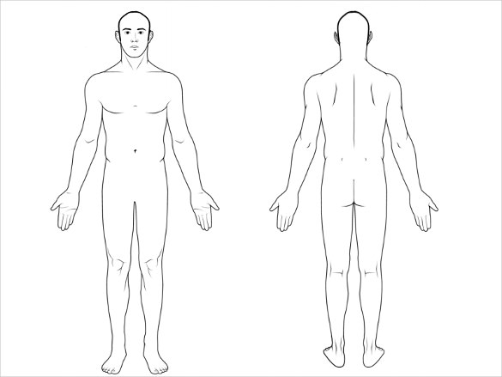

Are you currently taking any medications or supplements for your symptoms? Y or N
If Yes, what are you taking? ______________________________________________________

What are your goals for physical therapy? ___________________________________________

Medical History:
I have a history of (please circle all that apply):
High Blood Pressure Recent weight loss/gain
Heart Disease Lung disease
Diabetes Thyroid condition
Epilepsy Low blood sugar
Hearing loss Cancer
Asthma Impaired vision
Osteoporosis Fractures
Frequent falls Ringing in ears
Shortness of breath Dizziness
Angina (chest pain) Concussion
Arthritis Difficulty swallowing
Stroke Impaired memory
Depression Anxiety

Have you fallen recently? Y or N
Do you have a pacemaker or surgical implant? Y or N
Are you pregnant: Y or N
I have the following allergies: ______________________________________________________
Please list any serious illnesses, accidents, and/or surgeries: _____________________________
______________________________________________________________________________
______________________________________________________________________________
Please list all your medications: ____________________________________________________
______________________________________________________________________________
Have you been seen by a physical therapist before? Y or N
If yes, what for? ________________________________________________________________

How much caffeine do you consume daily? ________________
Do you smoke? Y or N If yes, how long have you been a smoker? _______ cigarettes/day? ___
How many days a week do you drink alcohol?

The above is true to the best of my knowledge.

Signature: Date:

Attendance Policy:
Consistent attendance and adherence to the planned treatment regimen is paramount to your care and recovery. We require a 24 hour cancellation notice for all appointments. If notice is not given, you may be charged a fee for the missed appointment.

Consent for Treatment:
I hereby authorize Dynamic Physical Therapy and Sports Conditioning to evaluate and treat my injury. I understand there is no guarantee that my condition will improve. I further understand that response to physical therapy evaluations and treatments vary from person to person and on rare occasions a treatment session may aggravate symptoms.

Notice of privacy practice:
Dynamic Physical Therapy and Sports Conditioning is committed to protecting our patients’ health information and privacy. In compliance with Federal HIPPA Regulations, therapists and staff will make their best efforts to ensure that your protected health information is kept private at all times. By signing below, I acknowledge that I may request a copy of Dynamic Physical Therapy and Sports Conditioning’s Notice of Privacy Practices.

Authorization To Release Protected Health Information:
I hereby authorize one or all of the designated parties listed below to request and receive the release of any protected health information

Name:________________________________________ Relationship:______ ________

Name:___________________________________________ __Relationship:_________ _____

Name:______________________________________________Relationship: ______________

Patient Name:_____________ ______________________________________

Signature:___________________________________________________ Date:______________

